Bishopswood Schools Federation

Volunteer Information



Thank you!

To begin, a massive thank you for volunteering at Bishopswood. We really appreciate you giving up your time to help us in the classroom. It makes a real difference to both the staff and children to have your support in whatever way you feel you can help us; whether that is once or more a week or less frequently.

We would like to have as many volunteers as possible, shared between the schools. If you have a child or children in the school, then you may or may not wish to help in their class. Please let us know your preferences.

Activities
When you work with children at school you will always be under the supervision of one of the teachers, who will let you know what they want you and the children to do. If you have specific skills which could be used in school, please let the teacher know and she/he will try and use your time and skills in the most productive way possible.

Hearing the children read is the most vital way in which you can help us. There are particular children in each class that for different reasons need extra support with their reading. The class teacher will give you a volunteer reading folder which will have the list of children we would like you to read with each time you come in.


Confidentiality
Occasionally in school you will become aware of information about children which is confidential or private to the child or their family. This is a delicate matter that requires a great deal of tact on your part. But, any conversation with parents outside is a breach of the school's confidence.

It is very important to treat anything you hear or see in school with regard to particular children as being in absolute confidence and entirely a matter within the school. Any information that leads you to believe a child is at risk should be mentioned to the class teacher who will deal with the information as appropriate.

Similarly you may find that parents who are friends will ask about the progress or behaviour of their children in school. Again, it is very important that you firmly suggest that if they are worried in any way about their child then they must discuss the matter themselves with the head or the class teacher.
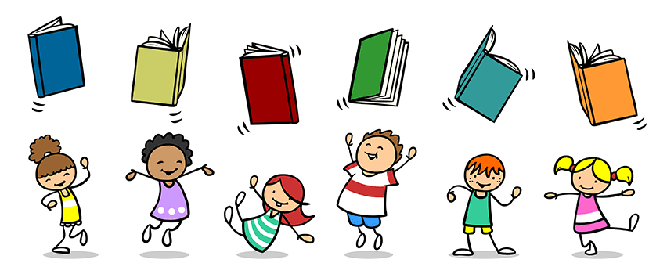

Safeguarding
To ensure the safeguarding and welfare of all our children at Bishopswood we will carry out a full enhanced DBS disclosure on any adult helping in school regularly who may be working alone with a group or child. These procedures will help us to identify anyone unsuitable to work with children. Please speak to the school office if you do not currently have a DBS and they will explain the process to you.

Behaviour Policy
We have a clear behaviour code in school, but there are a few children who need extra or different behaviour support. This will have been put in place in consultation with their parents, our SENCO and outside professionals. Therefore, you may see the staff dealing differently with a child because of a plan that has been put in place for that child.


Reading with a child - Infants

Using the ‘Monkey’ reading record books:
When you have heard a child read, please enter the page number that they have read up to. You may put a short positive comment e.g. good, well done, etc but we do ask that parents and helpers do not put any negative comments in the books or suggestions of what the child needs to do to improve. Please ensure that you initial the comment so we know who the child read with at a later date.
Changing Reading Books:
Books will usually be changed first thing in the morning, but this may vary from teacher to teacher and will usually be done with a member of staff in KS1 or Early Years. If you have any queries, please check with the teacher.
Reading Scheme
Our reading scheme is systematic in nature to ensure each child’s reading skills progress effectively. The children should have two reading scheme books in their book bag, in addition to a book at their level and a library book.

Reading with a child - Juniors

Please record how a child has got on in their reading record or diary. For example, you might write “Jonny was able to sequence the story of the book after he had read it” for a child on the red book band.

Our reading scheme is systematic in nature to ensure each child’s reading skills progress effectively. The children should have a reading book at their level in their book bag and a library book which you can share together.


Finally…
In case teachers forget to say so please be assured that they really do appreciate your help (they may be too busy or harassed to say so every week but they do!!) If you have any worries or queries please let us know.

