English / PSHE | Art & Design | Maths | Science | Outdoor Learning
Write an imaginary story about the journey of a flower. Explore the part that flowers play in the life cycle of flowering plants, including pollination, seed formation and seed dispersal. | 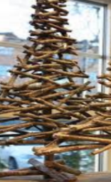  Make a sculpture of a tree. You can use anything you want to make it – try to be creative! Take a photo of it to show us. Or, write a few sentences to explain what you did. | Practice your timestables using Timestable Rock Stars. Can you beat your highest score? | Why do people need plants? Can you write a paragraph to explain the importance of plants to human life?  Plants use photosynthesis. This is a long, tricky, technical word. Can you research what it means and write a definition of the word? | 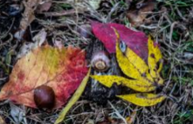  Collect three different kinds of leaves and stick them to a page in your home learning book. Can you identify which tree they come from?
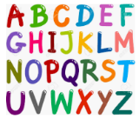  Can you think of a plant name that begins with every letter of the alphabet? You can use trees, flowers or plants. | 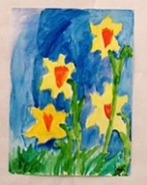  Create your very own flower painting. You could look at famous paintings too. | Have a look at some plants outside? What shapes do you recognise. Draw the plants and label the shapes you can see. | 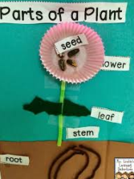  Use a range of different materials to label the parts of plant/and or flower. | Plant your own seed and watch it grow! You can take pictures of your gardening skills and write about what you have been up to. Keep a plant diary to show what happens.
Make your own ‘Top Tips’ poster for staying safe either  - Online  - On the roads  - In the sun | Choose a plant in your house or garden to sketch. Use a pencil and try to shade the drawing so that you can see different tones in the plant. | Create a pictogram to represent your family’s faviroute flowers. | Some plants use different defences to prevent them being eaten e.g. thorns, stings, poison. Design and label your own plant with defences. | 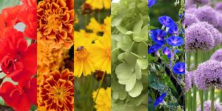  Go for a walk and see if you can find plants for each colour of the rainbow.
Make your own matching cards. You could create a match the fruit to the tree or match the seed to the plant. Ask someone to play with you and try to match your cards. | 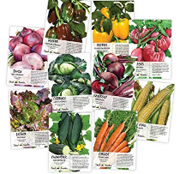  Can you design your own seed packet? Remember to invent your own growing instructions. Use the sheet provided, or make up your own. | Create 3 addition and subrtraction word problems using plants. Can you draw a picture to represent the word problem?  For example:  One flower has 4 petals. Another flower has 6 petals. How many petals are there altogether? | Design your own science experiment using plants. Write up your predictions before you carry it out. You could test two plants and change what conditions they have to grow in. | You can eat many different parts of a plant - leaf, stem, flower, seed, fruit. Can you make a list of parts that you like to eat and say which plant they’re from?
One piece of learning challenge homework must be completed each week ready to be handed in each Friday . You can stick it in to your green Home Learning Book, or simply tell us what you have done. Please feel free to make and create things that cannot be recorded in your book! This homework should take a minimum of 30 minutes and we hope it will be lots of fun.

